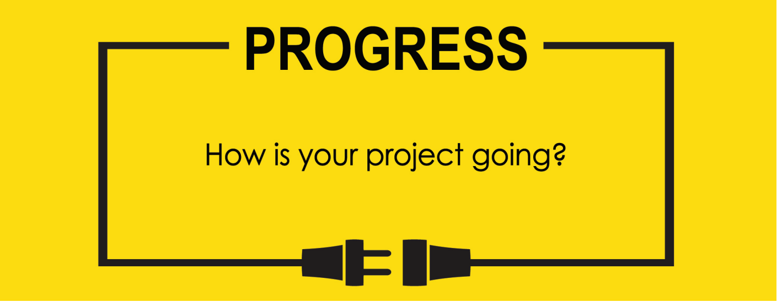

**Name: Zach Wilcox**

**Project Title: GreenBox**

**Previous Goals**

What were your three goals from last week? Were you able to complete them? If so, select Completed. If not, select the level of completion and explain in the Notes section why the goal was not completed, what still remains to be done, and when you expect to finish work on the goal.

Goal #1 from last week: Finish box build

**Status:** _____Completed ___x__Partially Completed _____No Progress

**Notes:**

More sides have been glued, but each piece must cure for a while before continuing, so final assembly has not been completed.

Goal #2 Finish GPIO output code

**Status:** _____Completed __x___Partially Completed _____No Progress

**Notes:**

Some progress has been made, but due to a complication in programming I reworked some of the input circuitry for the potentiometers so they can connect directly to the MCU, using more GPIO pins than before but less complicated code. Because of this and some debugging, I was not able to finish the output code that relies on said input code to run.

Goal #3 Test I/O for sensor to system control

**Status:** _____Completed _____Partially Completed __x___No Progress

**Notes:**

I was anticipating being finished with goal #2 to move on to this step, and due to that not being completed I could not move on to this portion.

**Next Three Goals**

Choose three subtasks from your Gantt chart and use them to form goals that you plan to complete this week. In the text box beneath each goal, give details about what you plan to accomplish. Include details such as what materials are needed, how many hours each day you plan to devote to the task, and so on.

NOTE: THESE ARE INDIVIDUAL GOALS THAT YOU PLAN TO ACCOMPLISH. THESE ARE NOT TEAM GOALS.

**Goal #1:** Finish box build

**Goal #2:** Finish input/output software

**Goal #3:** Test input/output software

Potentiometers will now each connect directly to their own GPIO port connected to the ADC instead of using a decoder and sampling.

Old Gantt chart

Yet again pushed back all aspects of development

